Counting methods
Question #2.
a)
Number of letters= 26 (A to Z)
Number of digits=10 (0 to 9)
In a 7-place license plate the 3 letters can take any of 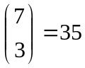possible positions.
For these 35 possible positions 3 letters and 4 digits can be placed in any of
=35*26*26*26*10*10*10*10 =35* 26³*10⁴
= 6151600000 ways
b) Possible plates with no repetition in digits =35*26³*10*9*8*7= 3100406400 ways
Question #3:
True
Question #4:
4*3*4=48 ways
Question #5:
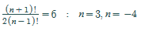
Question #6:
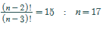
Option is C
Question #7:
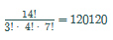
Question #9:
¹²C₂*¹⁰C₁=66*10=660
Question #10:
¹⁰C₂*⁸C₂=45*28=1260
Option is C
Question #11
: 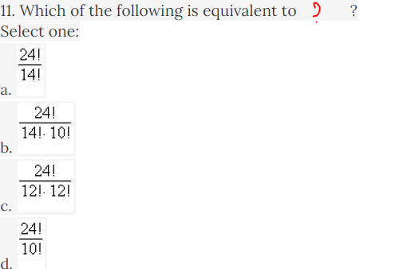
Question #12:
¹²C₅=792
Question #13:
8, 2
7,2
Question #14:
a) There are 12 letters from a to l. Since it is a 4 letter code with no restrictions, the number of possible combinations is 12⁴= 20,736 possible combinations.
b) % of the codes that repeat at least 1 letter= 100% - % of codes that do not repeat any letter.
% of codes that do not repeat any letter= number of codes that don't repeat any letter / total number of possible combinations= (12 x 11 x 10 x 9)/ 20,736= 57.292%.
% of the codes that repeat at least 1 letter= 100% - 57.292%=43%
Question #15:
6*4*6*3=432
Option is A
Question #16:
Option is C512
Question #17:
60*60=3600
Option is C
Question #18:
6+3=9
Option is D
Question #19:
9*10*10*10*5=45000
Option is D
Question #21:
c. factorial
Question #22:
₈₋₂P₂=30
n=8
Option is D
Question #23:
1, 1, 1,1
2, 1, 2,1
Question #24
a) There are n letters and 2 positions they can be placed in.
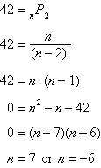
Since n must be a positive number, Vito is thinking of a 7-letter word.
b)
SOLVING or GOLFERS

Question #25
c. 2520
Question #26:
₃₄P₁=34
r=1
Question #27:
Option is C 28
Question #28:
120
Question #29
2*9! Option is B
Question #30:
9 465 511 770

Probability:
Question #3:
P (windy and win) = 0.30 x 0.50= 0.15
P (calm and win) = 0.70 x 0.70 = 0.49
P(win) = P (windy ∩ win) + P (calm ∩ win)
P(win) = 0.15 + 0.49
P(win) = 0.64
The probability that Debra’s team will win tomorrow is 64%.
Question #4
Option is D
Question #5:
₃₀C₁/₁₀₀C₁=0.3
Option is 0.3
Question #6
(5/175)*(4/174)=0.000657
Question #7:
P(A)+P(B)+P(C)+P(D)=1
0.4+0.1+0.25+0.25=1
P(C)=0.25
Question #8
Option D 1/3
Question #9
b. Rolling a 4 and rolling a 5 with a pair of six-sided dice, numbered 1 to 6.
Question #10
P(F)=0.6
P(C)=0.8
P(F∩C)=P(F)*P(C)=0.6*0.8=0.48=48%
Question #11
Option is C33.4%
Question #12:
P ( A ) = 0.9, P ( B ) = 0.23, and P ( A ∩ B ) = 0.207
Option is D
Question #13:
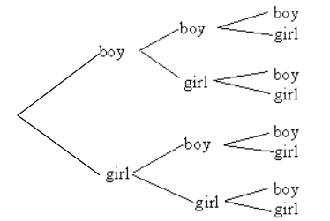
Option is B 25%
Question #14:
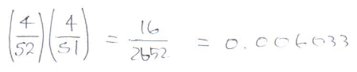
Option is A
Question #15:
(1-35/36)+(18/36)=0.5278
Question #16:
C. 7/13
Question #17:
Option is D
Question #19
NO, 2 is prime ever
Question #20:
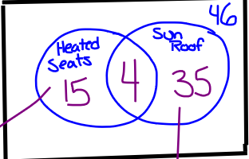
46% have neither . So 100% -46%=54%
54% must have at least one. But 19%+39%=58% , so 4% must have been counted twice(the intersection is 4%)
Therefore, 4% have both.

Question #21:
Unfav:Fav
Lose:Win
P(Z)=2/5=4/10
P(B)7/10=7/10
Question #22:
c. 7 : 3
Question #23:
d. 5 : 3
Question #24:
Fav :6
Unfav:10-6=4
Fav : Unfav
6 : 4
3: 2
Question #25:
P=₄P₄/₁₂P₄=1/495=0.2%
Question #26:
₂P₂
Option is A
Question #27:
c. 8
Question #28:
Fav=(1/7)&9*10*10=900
Total=10*10*10*9=900
P_{r}=Fav/Total=900/9000=0.10 or 10%
Question #29:
The process of theorizing , however, shares with experimentation a creative and open-ended character.
Question #30:
The experiment is tossing a coin, the sample space is typically the set {head, tail}, commonly written {H, T} and for tossing a single six-sided die, the typical sample space is {1, 2, 3, 4, 5, 6} (in which the result of interest is the number of pips facing up).

Question #31:
Two events are mutually exclusive if they cannot occur at the same time. Another word that means mutually exclusive is disjoint.
If two events are disjoint, then the probability of them both occurring at the same time is 0.
Disjoint: P(A and B) = 0
If two events are mutually exclusive, then the probability of either occurring is the sum of the probabilities of each occurring.
Question #32:
An independent event is an event in which the outcome isn't affected by another event. A dependent event is affected by the outcome of a second event.
Cards are often used in probability as a tool to explain how one seemingly independent event can influence another. For example, if you choose a card from a deck of 52 cards, your probability of getting a Jack is 4 out of 52. Mathematically, you can write it like this:

